FORNAX™ ePlanCheck Rule
Rule Information
Rule ID | SSW 3.2.3.3 (d)
Rule Name | Provision for Cross Venting
Chapter | Part 3 Sanitary Works
Section | 3.2.3 Acceptable Design/Practice
Handbook | Code of Practice on Sewerage and Sanitary Works  Addendum No. 2 - Nov 2004

Rule Description
      - Ventilated Stack Sanitary Plumbing System

- Cross venting between the ventilating stack and the discharge stack shall be provided at third, sixth, ninth, twelfth, fifteenth, eighteenth, twenty-first, twenty-fourth and twenty-seventh storeys.

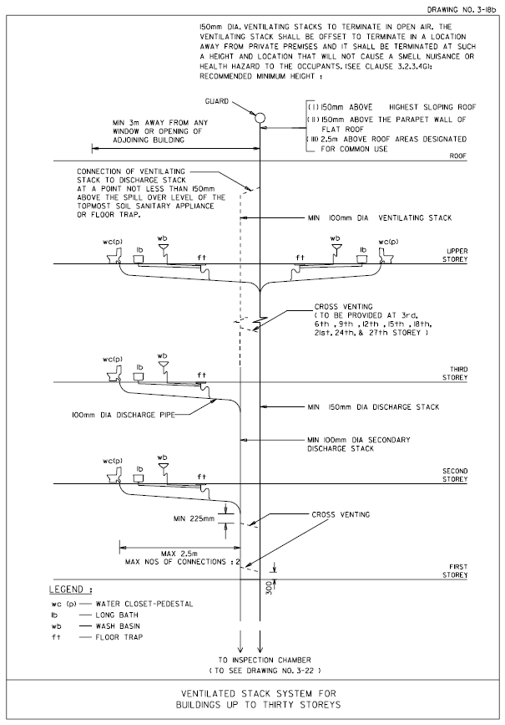

Drawing No. 3-18b
FIGURE 01

Rule Interpretation
- This rule checks for cross venting between a ventilating stack and a discharge stack for buildings up to 30 storeys high.
- Cross venting should be provided at the third, sixth, ninth, twelfth, fifteenth, eighteenth, twenty-first, twenty-fourth and twenty-seventh storeys (3rd, 6th, 9th, 12th, 15th, 18th, 21st, 24th and 27th storeys).
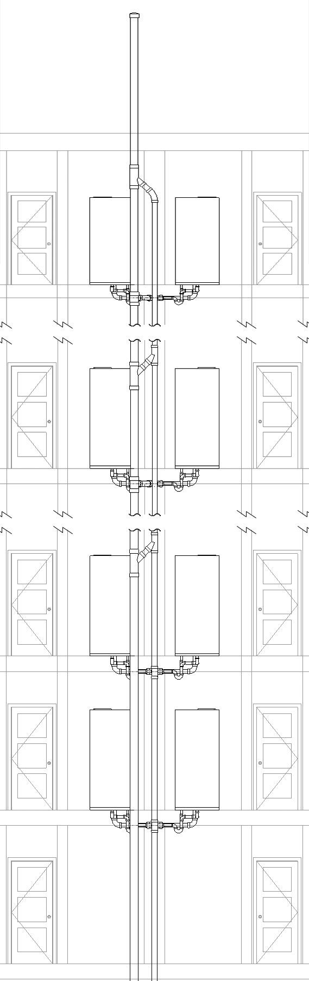
LEVEL 1

CROSS VENTING
(FIGURE 02)

LEVEL 2

LEVEL 3

LEVEL 6

LEVEL 30

SECTION VIEW
FIGURE 01

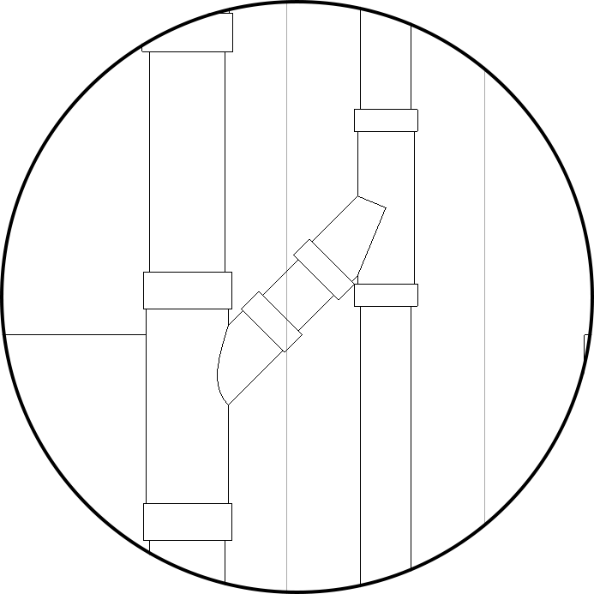

CROP VIEW OF CROSS VENTING
FIGURE 02

Rule Scenario

Scenario 01 – Compliant
Requirement | Cross venting should be provided at the third, sixth, ninth, twelfth, fifteenth, eighteenth, twenty-first, twenty-fourth and twenty-seventh storeys (3rd, 6th, 9th, 12th, 15th, 18th, 21st, 24th and 27th storeys).
Description | Compliant; cross venting provided at the third, sixth, ninth, twelfth, fifteenth, eighteenth, twenty-first, twenty-fourth and twenty-seventh storeys (3rd, 6th, 9th, 12th, 15th, 18th, 21st, 24th and 27th storeys).
SECTION

FIGURE SCENARIO
First Storey Level

Second Storey Level

Third Storey Level

Sixth Storey Level

Ninth Storey Level

Twelfth Storey Level

Fifteenth Storey Level

Eighteenth Storey Level

Twenty First Storey Level

Twenty Fourth Storey Level

Twenty Seventh Storey Level

Twenty Eighth Storey Level

Twenty Ninth Storey Level

Thirtieth Storey Level

Cross venting provided

Cross venting provided

Cross venting provided

Cross venting provided

Cross venting provided

Cross venting provided

Cross venting provided

Cross venting provided

Cross venting provided

Scenario 01 – Non-Compliant 1
Requirement | Cross venting should be provided at the third, sixth, ninth, twelfth, fifteenth, eighteenth, twenty-first, twenty-fourth and twenty-seventh storeys (3rd, 6th, 9th, 12th, 15th, 18th, 21st, 24th and 27th storeys).
Description | Non Compliant; cross venting missing at one or more of the required levels
SECTION

FIGURE SCENARIO
First Storey Level

Second Storey Level

Third Storey Level

Sixth Storey Level

Ninth Storey Level

Twelfth Storey Level

Fifteenth Storey Level

Eighteenth Storey Level

Twenty First Storey Level

Twenty Fourth Storey Level

Twenty Seventh Storey Level

Twenty Eighth Storey Level

Twenty Ninth Storey Level

Thirtieth Storey Level

Cross venting missing

Cross venting provided

Cross venting provided

Cross venting provided

Cross venting provided

Cross venting provided

Cross venting missing

Cross venting provided

Cross venting provided

Scenario 01 – Non-Compliant 2
Requirement | Cross venting should be provided at the third, sixth, ninth, twelfth, fifteenth, eighteenth, twenty-first, twenty-fourth and twenty-seventh storeys (3rd, 6th, 9th, 12th, 15th, 18th, 21st, 24th and 27th storeys).
Description | Non Compliant; cross venting provided at one or more wrong levels
SECTION

FIGURE SCENARIO
First Storey Level

Second Storey Level

Third Storey Level

Sixth Storey Level

Ninth Storey Level

Tenth Storey Level

Fifteenth Storey Level

Eighteenth Storey Level

Twenty Second Storey Level

Twenty Fourth Storey Level

Twenty Seventh Storey Level

Twenty Eighth Storey Level

Twenty Ninth Storey Level

Thirtieth Storey Level

Cross venting provided

Cross venting provided

Cross venting provided

Cross venting at wrong level

Cross venting provided

Cross venting provided

Cross venting at wrong level

Cross venting provided

Cross venting provided

Request For Information
- Is cross venting still necessary for buildings higher than 30 storeys?

Rule Parameters

System Type
Cold Water
Hot Water
 | Sanitary | 
 | Sewerage
Vent

Element Type 1
State | Type | Property | Operator | Value
Include | IfcBuildingStorey | IfcName | Contains | Level 3
Include | IfcBuildingStorey | IfcName | Contains | Level 6
Include | IfcBuildingStorey | IfcName | Contains | Level 9
Include | IfcBuildingStorey | IfcName | Contains | Level 12
Include | IfcBuildingStorey | IfcName | Contains | Level 15
Include | IfcBuildingStorey | IfcName | Contains | Level 18
Include | IfcBuildingStorey | IfcName | Contains | Level 21
Include | IfcBuildingStorey | IfcName | Contains | Level 24
Include | IfcBuildingStorey | IfcName | Contains | Level 27

Element Type 1
State | Type | Property | Operator | Value
Include | IfcFlowSegment | IfcDescription | Contains | Cross Vent Pipe
Include | IfcFlowFitting | IfcDescription | Contains | Cross Vent Tee 01
Include | IfcFlowFitting | IfcDescription | Contains | Cross Vent Tee 02

Result Messages
- 8.3.3 Ventilated Stack Sanitary Plumbing System
- Non-compliant (1) (TotalResultNumeric)
- BuildingStorey (TotalResultPerFloorNumeric)
  - ElementType1Name
  - ElementType2Name is not provided.

- Non-compliant (2) (TotalResultNumeric)
- BuildingStorey (TotalResultPerFloorNumeric)
  - ElementType1Name
      - ElementType2Name at wrong level.

- Compliant (1) (TotalResultNumeric)
- BuildingStorey (TotalResultPerFloorNumeric)
  - ElementType1Name
  - ElementType2Name provided.
  - ElementType2Name at correct level.

- Attention (TotalResultNumeric)
- BuildingStorey (TotalResultPerFloorNumeric)
- No ElementType1 found.

Sample Result Messages
- 8.3.3 Ventilated Stack Sanitary Plumbing System
- Non-compliant (1)
  - Level 3, 6, 9, 12, 15, 18, 21, 24, 27
  - Cross vent pipe is not provided.

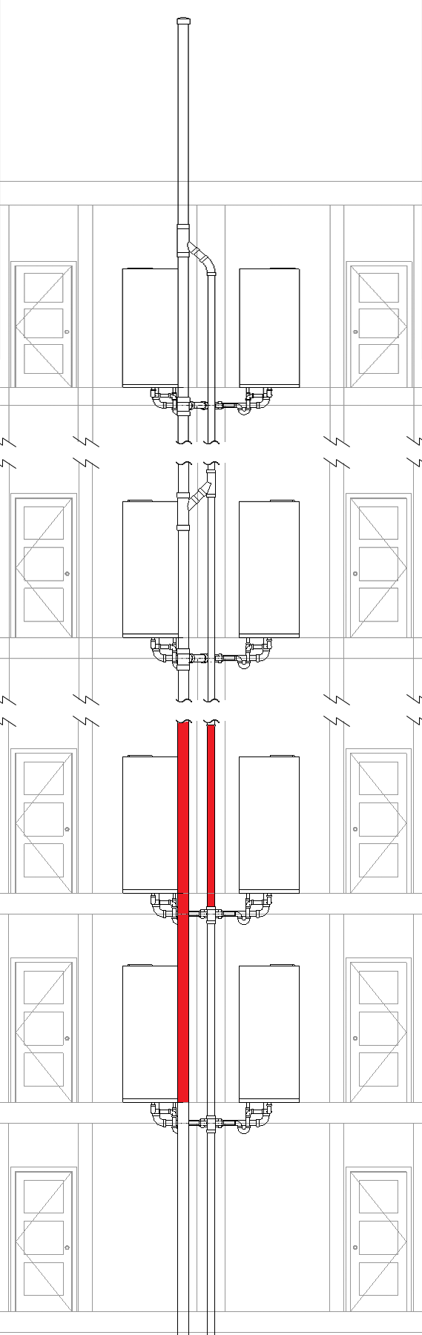
LEVEL 1

LEVEL 2

LEVEL 3

LEVEL 24

LEVEL 30

- Non-compliant (2)
  - Level 3, 6, 9, 12, 15, 18, 21, 24, 27
      - Cross vent pipe at wrong level.

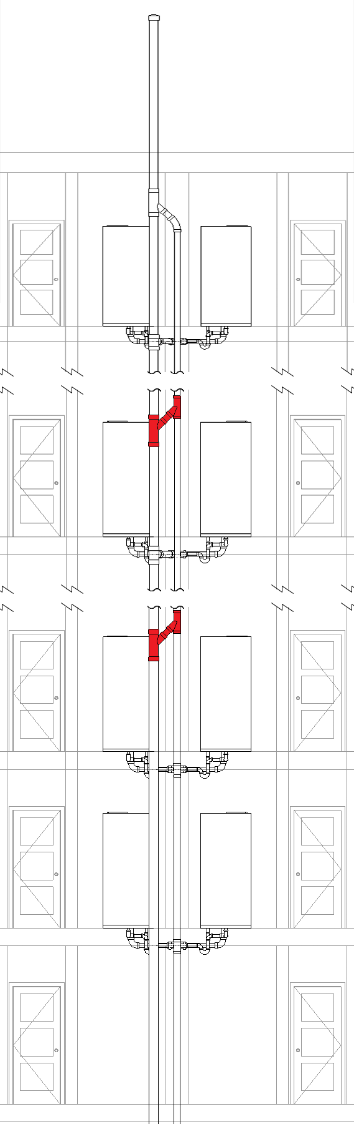
LEVEL 1

LEVEL 2

LEVEL 10

LEVEL 20

LEVEL 30

- Compliant (1)
  - Level 3, 6, 9, 12, 15, 18, 21, 24, 27
  - Cross vent pipe provided.
  - Cross vent pipe at correct level.

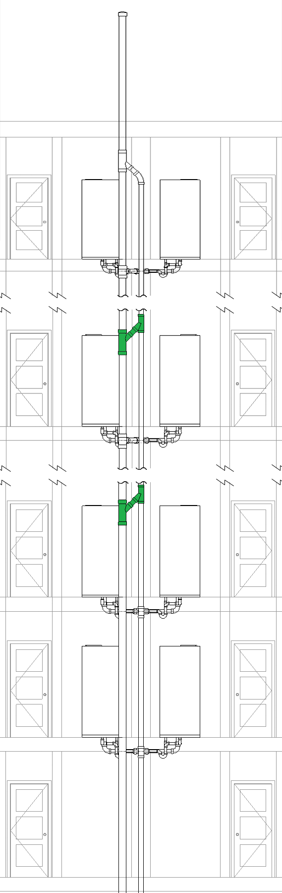
LEVEL 1

LEVEL 2

LEVEL 3

LEVEL 6

LEVEL 30

Testing Scenario Notes

Modelling Guideline

Specification Log
RA | Karl Bautista
Last edit date | 05 October 2018
ePC version
Updates | Created RI and UAT Models for Revit and Archicad

